Task-Based Activity: Interpret a flight price table
Laubach Connection: Laubach Way to Reading (LWR) Book 3, Lesson 14
OALCF Link
Relevant Goal Paths
Apprenticeship, Employment, Independence, Postsecondary, Secondary School Credit
Rationale: Learners on the Apprenticeship, Employment and Independence Paths will need to read tables with flight pricesfor a variety of different reasons.

Task-Based Activity Description: The learner will interpret a simple document (flight price table) to locate and connect information (A2.2).
Competency, Task Group and Level Indicators
(See Assessment page for performance descriptors)
A: Find and Use Information
A2: Interpret documents
- A2.2: Interpret simple documents to locate and connect information

Materials Required
- Pen or pencil and eraser
- Question sheets

Overview
Activity Introduction
This task uses atable with flight prices. The learner will examine the table and use its contents to answer the questions.

New words
Determine any new words that you think are being introduced in the activity and review those words with the learner.

Instructions
- Have the learner fill in their name and the date.
- Have the learner complete the pre self-assessment.
- Have the learner complete the task-based activity.
- After completing the activity, have the learner complete the post self-assessment.
- After the learner has completed the task-based activity, complete the assessment section and review the results with the learner.

Extension activities
- Bring in a variety of different labels for the learner to interpret.
- Have the learner bring in labels from home that they are having difficulty understanding.

Task-Based Activity: Interpret a flight price table

Learner Name: _____________________________ Date: ____________________________

Pre self-assessment

I need to improve my skills at locating information in tables:
- Yes
- No

Activity
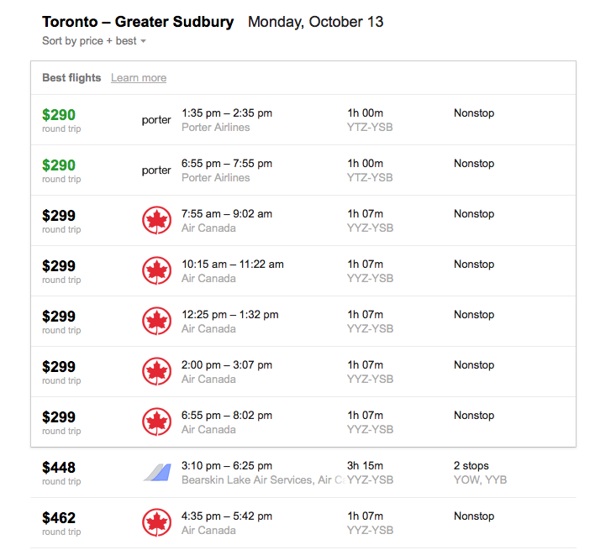

- Where do these flights leave from and go to? __________________________________________________________________
- You need to be in Sudbury by 2:40 pm. Which flight should you take? __________________________________________________________________

- Which company provides the cheapest flight? __________________________________________________________________

- Which company stops twice on the way to Sudbury? __________________________________________________________________
- How long is the shortest flight? __________________________________________________________________
- Based on price, times, and number of stops, choose the best flight for you to take a trip from Toronto to Sudbury. Explain. ________________________________________________________________________________________________________________________________________________________________________________________________________________________________________________________________________

Post self-assessment
I think my skills have improved as a result of completing this activity.
- Yes
- No
Learner comments:
______________________________________________________________________________
______________________________________________________________________________
______________________________________________________________________________

Assessment
Task-Based Activity: Interpret a flight price table
Learner Name: ____________________________ Date: ____________________________

Practitioner Name: _______________________________________

Performance Descriptors | Needs Work | Improving | Excellent
A2.2: Interpret simple documents to locate and connect information
- performs limited searches using one or two search criteria
- extracts information from tables and forms
- locates information in simple graphs and maps
- uses layout to locate information
- makes connections between parts of documents
- makes low-level inferences
- begins to identify sources and evaluate information
The learner needs to work on the following:

This task was successfully completed ______ This task needs to be tried again ______

Practitioner Comments:

Learner Comments:

